|  |  |
| --- | --- |
| Internship Project Title | Operations Management - Inventory Module using MERN Stack |
| Name of the Company | TCS iON |
| Name of the Industry Mentor | Debashis Roy |
| Name of the Institute | Madras Institute of Technology, Anna University |

|  |  |  |  |  |  |  |
| --- | --- | --- | --- | --- | --- | --- |
| Start Date | End Date | | Total Effort (hrs.) | | Project Environment | Tools used |
| 12-07-2022 | 16-07-2022 | | 23.5 | | VS Code, Windows, Firefox | NodeJS with Express, MongoDB Atlas, React, several npm packages |
| Milestone # | 1 | Milestone: | | Install and configure necessary software for the MERN Stack and complete action item 1 (Inventory submodule) | | |

**TABLE OF CONTENT**

* Acknowledgements
* Objective
* Introduction / Description of Internship
* Internship Activities
* Approach / Methodology
* Assumptions
* Exceptions / Exclusions
* Charts, Table, Diagrams
* Algorithms
* Challenges & Opportunities
* Risk Vs Reward
* Reflections on the Internship
* Recommendations
* Outcome / Conclusion
* Enhancement Scope
* Link to code and executable file
* Research questions and responses

# Acknowledgements

I thank TCS iON and the industry mentor for their guidance and support as well as for providing necessary information regarding the project.

# Objective

The objective of this project is to develop an automated software for Inventory Management module of Operations Management using MERN Stack.

# Introduction/Description of Internship

A method through which you keep track of your products across the whole supply chain, from purchase to manufacture to final sales, is known as an inventory management system (or inventory system).

It controls how you go about managing your company's inventory.

The goal of this project is to create an automated software system utilizing MERN Stack for the Operations Management Inventory Management module.

# Internship Activities

Some of the activities to be done during the internship include Pre-project test, activity report, interim project reports, final project report, project test.

# Approach / Methodology

1. Initially we create a backend server using node to serve and process requests from the client. The backend also communicates with the database(MongoDB) and retrieves / stores information.
2. For this project I have used a local MongoDB Server and user Mongo DB Compass for access it.
3. We then model the data items to be stored in the database. This is done with the mongoose package which helps in data modeling for MongoDB.
4. The models are defined with mongoose schemas.
5. The frontend is made with React, a java script library for building user interfaces.
6. The frontend communicates with the backend by making get/post and other methods of requests to enable the various functions of inventory management.We create Backend APIs for these functionalities
7. Items, item groups and adjustments are the data models created.
8. Each item belongs to an item group and adjustments can be made to the quantity/value of the items.
9. The Items,Item Groups and Adjustments can be Viewed and Updated

# Flow diagram

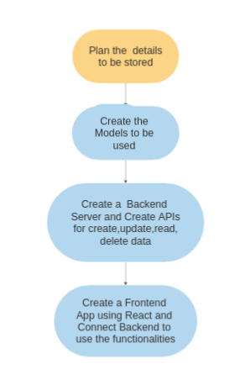

# Algorithms

We use some algorithms to validate the form date . Perform some operations on data to be stored on MongoDB

Reflections on the Internship

I'm hoping that working as an intern with TCS ion will allow me to learn and get a practical knowledge on the MERN stack!

# Enhancement scope

There is a lot of scope for improvement of this inventory module.

For instance, instead of Manually entering the data we can update the data real-time by some devices

# Link to code

GitHub repository with documents submitted till now and also the code for the project: https://github.com/Prabakaran2712/tcs-remote-internship